How to mount /mnt/windows on server FIAUS01 server.

- Take Remote Desktop Connection
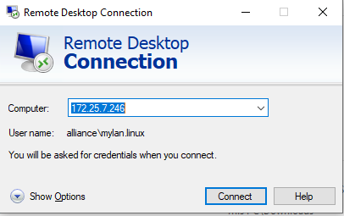

- Enter user name and password as mentioned below.
Computer name: - 172.25.7.246
User name: alliance\mylan.linux
Password: ]K^{<-R>Qe%7fd\5CbrL=UC3Y_9se^Y8
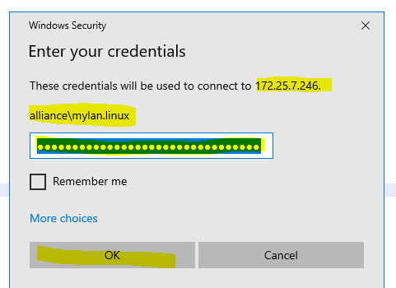

After login above form desktop open putty and login with below IP and password
Username : root
spinisa999
10.118.255.9

After that you can follow steps or you can follow standard steps as for document
cifsmount akhisabex01.alliance.net:/sap_backup /mnt/windows -U administrator
#akhisabex01.alliance.net:/sap_backup /mnt/windows cifs rw,username=administrator,password=P@ssw0rd,uid=60838,uid=60843,gid=201,defaults 0 0
cifsmount
cifsmount akhisabex01.alliance.net:/sap_backup /mnt/windows cifs rw,username=administrator,password=P@ssw0rd,uid=60843,gid=201,defaults 0 0
cifsmount akhisabex01.alliance.net:/sap_backup /mnt/windows -U administrator
su - p2aadm
bdf /mnt/windows

- Check the /mnt/windows mount point is mounted or not?
# bdf /mnt/windows

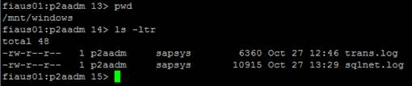

- Run the below command for mount /mnt/windows
# cifsmount akhisabex01.alliance.net:/sap_backup /mnt/windows -U administrator

- Give the administrator password
# password=P@ssw0rd

- Now check the /mnt/windows mount point is mounted or not?
# bdf /mnt/windows
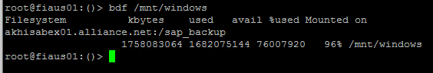

- After mount Switch to p2aadm user
# su - p2aadm
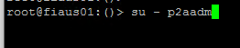
- Run the cifslogin command
# cifslogin akhisabex01.alliance.net -U administrator

- Give the administrator password
# password=P@ssw0rd

- Check the p2aadm user status with the command mentioned below.
# cifslist -u

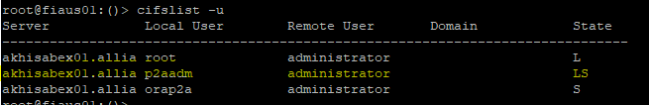

Note: Above the screenshot it is showing LS it means it is working properly
- Exit from p2aadm
- Switch to orap2a user
# su - orap2a
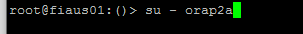
- Run the cifslogin command
# cifslogin akhisabex01.alliance.net -U administrator

- Give the administrator password
# password=P@ssw0rd
- Check the orap2a user status with the command mentioned below.
# cifslist -u

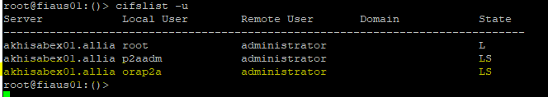

Note: : The above screenshot is showing LS it means it is working properly.

